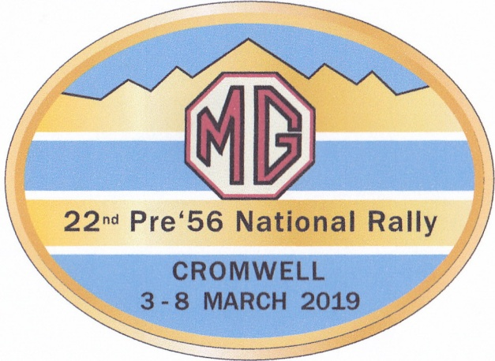

We are looking forward to welcoming you to Cromwell for the 2019 Pre’56 MG Rally.
Cromwell is a special place to explore, of natural charm and heritage. The beauty of the area is overwhelming, being situated beside the meeting of two rivers, the sparkling waters of Lake Dunstan and a rugged mountain backdrop.
Cromwell basin is home to a host of award winning wineries. Soak in the scenery while enjoying some of the world’s finest Pinot Noir.
The area has a rich heritage with remnants of goldfields that will take you on a journey to the past. Wander down to the historic Cromwell Heritage Precinct for a selection of boutique shops, art galleries and cosy cafes.
Cromwell is also home to the famous Highlands Motorsport Park, a popular visitor attraction, and venue for our Speed Event.

THE RALLY HEADQUARTERS & ACCOMMODATION:
Rally HQ will be The Gate: Harvest Hotel and Conference Centre in Cromwell Cnr SH8B & Barry Ave. They have 47 rooms set aside for Rally participants.
Bookings: info@thegate.nz Free phone: 0800 104 451 Phone: +64 3 445 1777
When booking mention ‘Pre ’56 MG Rally 2019’ to obtain a discounted price of $145 per night/per couple (Breakfast not included)
The following motels are also available and close to the Rally HQ and Harvest Hotel.
Carrick Lodge Motel, 10 Barry Ave, 0800 445 495
Colonial Manor Motel, 14 Barry Ave, 0800 428 648 ASURE
Central Gold Motel, 24 Barry Ave, 03 445 4700
Lake Dunstan Motel, 3 Mead Ave, 0800 666 919
Elsewhere in Cromwell there is a good selection of accommodation available to suit all requirements. However demand for accommodation is high in March so we advise early bookings.
We suggest that you contact the accommodation providers directly and negotiate best rates. Other accommodation sources include: www.tripadvisor.com, www.bachcare.co.nz. www.bookabach.co.nz

RALLY PROGRAMME:

Sunday 3rd March: Registration, Noggin ‘n’ Natter, Welcome dinner.
Monday 4th March: Concours d’etat
Tuesday 5th March: Scenic Trial
Wednesday 6th March: Gymkhana and Register Dinners
Thursday 7th March: Speed Event and Prize Giving Dinner
Friday 8th March: Farewell Breakfast

The programme is designed to not only offer all the usual MG Rally events but also ensure there is some time to relax or explore and enjoy Cromwell and the surrounding district.
Entry Forms for the Rally will be available on your local MGCC Centre’s website shortly.

Kind Regards

Wayne & Billee Marsh

Contacts: Ph 03 445 2266 or email waynemarsh@xtra.co.nz

MGMGMGMGMGMGMGMGMGMGMGMGMGMGMGMGMGMGMGMGMGMGMGMGMG

